**Answer Sheet for Lab 3**

**Part 1**

a) High Logic Level

b) High Logic Level

c) High Logic Level

d) Low Logic Level

**Part 2**

a) 48 pins are used

b) 3.3 volts

**Part 3**

Attach screenshot here (or submit as a separate file)

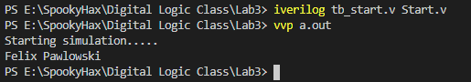

**Part 4**

Does your design work on your board? Yes